API DAY 3(DATA TYPES & JSON CODE SYNTAX)

- CREATE OWN API

Download Software:
Node JS: NPM (node package manager) – this will come automatically
Jason server: open cmd – npm install -g json-server - enter

- Create JSON code in notepad and extension should be ends with JSON - name.json
- Go to this file path and in top open with cmd on the path of file
- C:\Users\Atmin\Desktop\Automation\jsonfiles>json-server students.json in cmd
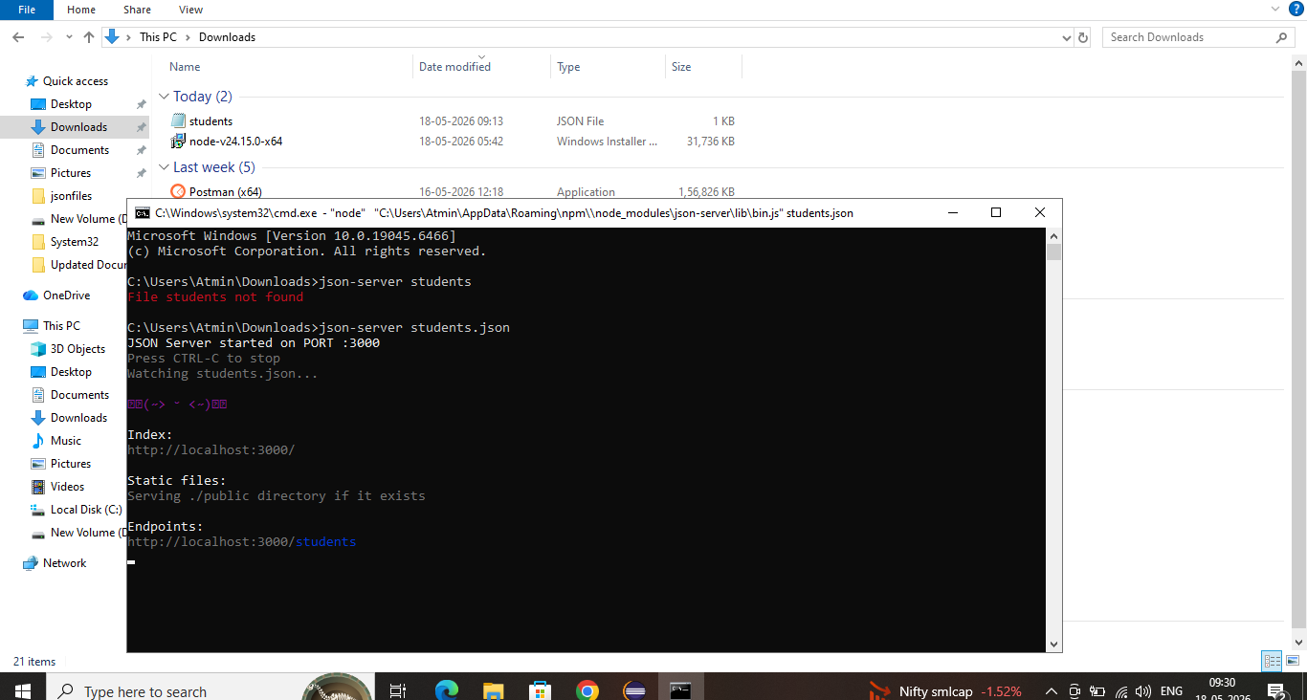

- Endpoints: http://localhost:3000/students open this link in chrome now we created own api – this link will be generated in cmd after doing above 3 steps
- Now in postman create workspace and do the get post put delete works

- JSON:

- Data types: {key : value} – Key will be in “ “
- Number: {“number”: 28}
- String: {“name” : “Thasif”}
- Boolean: {“sale” : true}
- Null: {“middlename”: null}
- Object: {“name” : “Thasif” , “Number” : 20}
- Array: {“name” : [“ Thasif ”, “ Ahamed ”] } // more than one value store in array

Syntax Structure of json – Array with objects
{
“Students”: [
{
“sid” : 101,
“sname” : “Thasif”,
“grad”: “A”
},
{
“sid” : 102,
“sname” : “Ahamed”,
“grad”: “A”
}
]
}
Nested Structure of json Syntax – Array with objects
{
"employees": [
{
"id": 1,
"name": "Thasif Ahamed",
"email": "thasif@example.com",
"phone": "9876543210",
"salary": 45000.50,
"isActive": true,
"department": null,
"skills": [
"Java",
"Selenium",
"API Testing"
],
//object
"address": {
"city": "Puducherry",
"pincode": 605001
}
}
]
}

- Json Path
Note: I want to extract the name data only from the 1st student:
Students[0]. Sname this will extract the 1st object student name only
This is very easy because we have only 3 objects in student API. But in real project we will have multiple data for that we have to use below 2 tools link
- https://jsonpathfinder.com/ (This will give exact JSON path for which value we need)
- https://jsonpath.com/ (This help to check our json values is correct or not)

